|  |
| --- |
| WEB PAGES VALIDATION TEST RESULTS |
| **[**Phone]  **[**Email]  [Website] |

INTERNET SERVICE PAGE

* There is no bread crumbs in the banner.



* Explore more button doesn’t exist. ((this photo from xd))



* Left padding have to be smaller as the design((major post launch))



* “Internet Fiber” have to be “Home Internet Fiber”

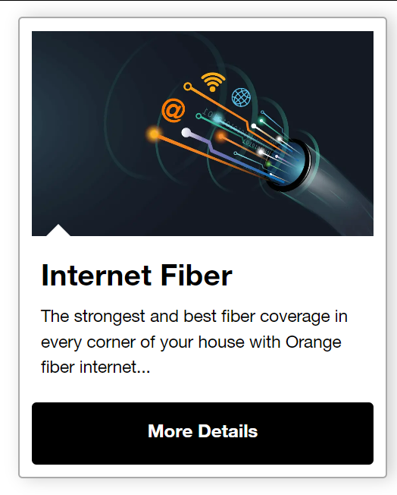

* “4G fly box” have to be “4G Home Internet” ALSO “Internet ADSL” have to be “ADSL Home Internet”

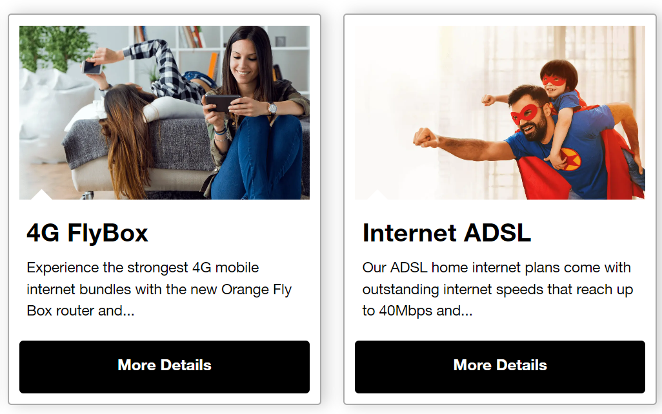

* Those links open in new tab not on the same tab

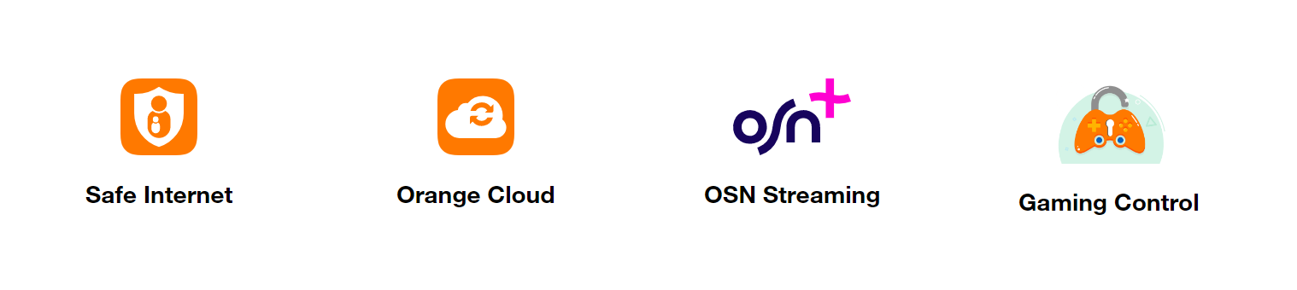

* SVG image have to be a man wears headphones and the Need Support link opens in new tab.

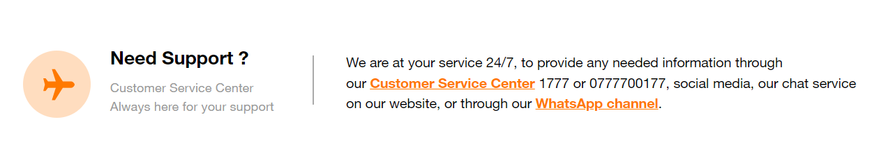

PHONE RESPONSIVE TEST:

* Bread crumbs doesn’t exist.

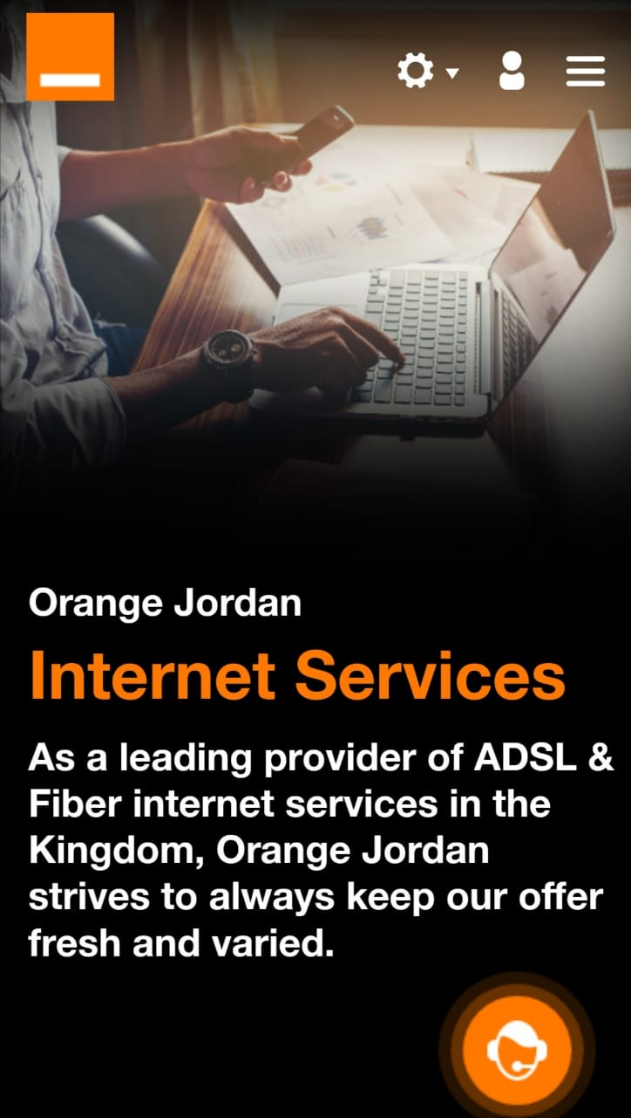

* There is no arrow at the right of this section also there is no underline so it doesn’t give the user indicate that there is a link in there.

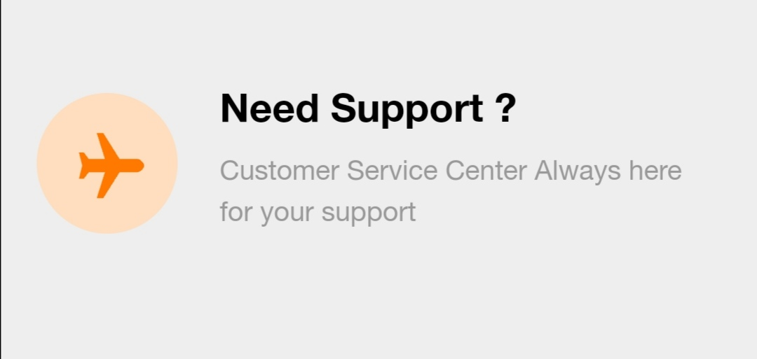

TABLET RESPONSIVE TEST:

* Missing the personal tab.



ORANGE CLOUD PAGE

* Back button does not exist in the banner and the bread crumbs is missing the personal tab.



* Left padding have to be smaller as the design((major post launch))



* Cloud link doesn’t exist ((WAF point))

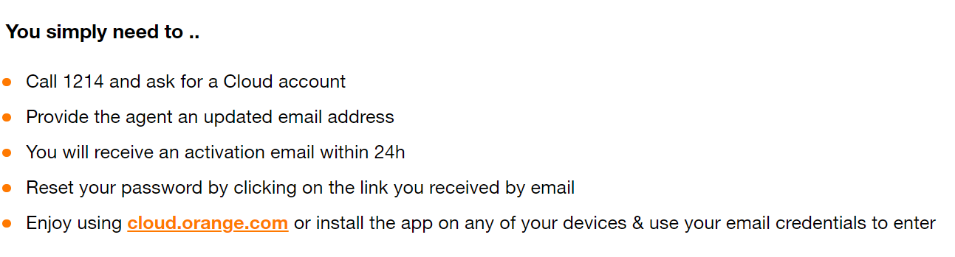

* Links here open on the same tab and in new tab.

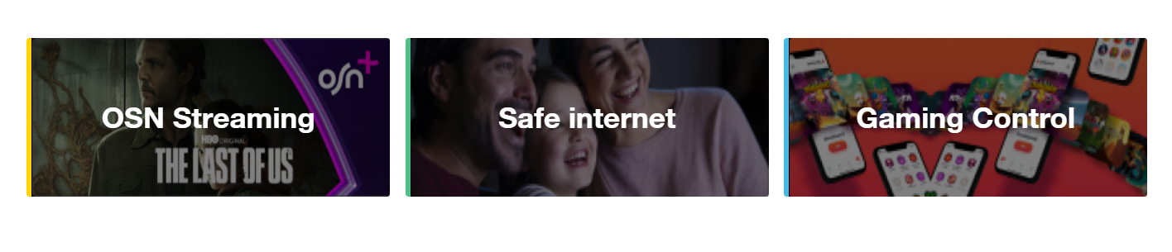

* SVG image have to be a man wears headphones and the Need Support link opens in new tab.



* After swapping between Mobile and Fiber tabs the content still the same.

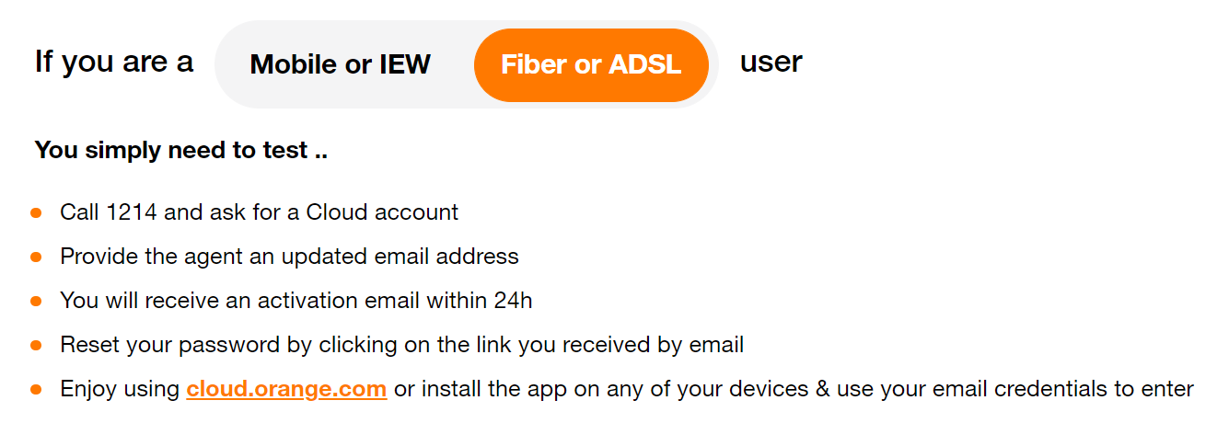

* Orange Cloud should be a link.



PHONE RESPONSIVE TEST:

* Bread crumbs doesn’t exist.

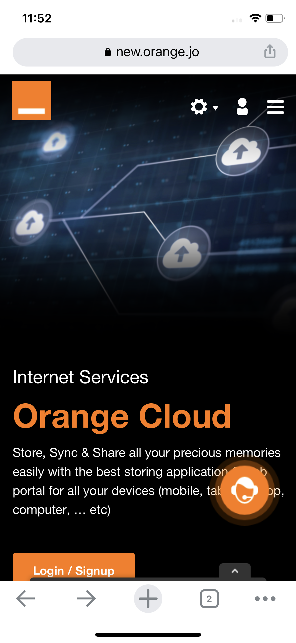

* There is no arrow at the right of this section also there is no underline under need support sentence.

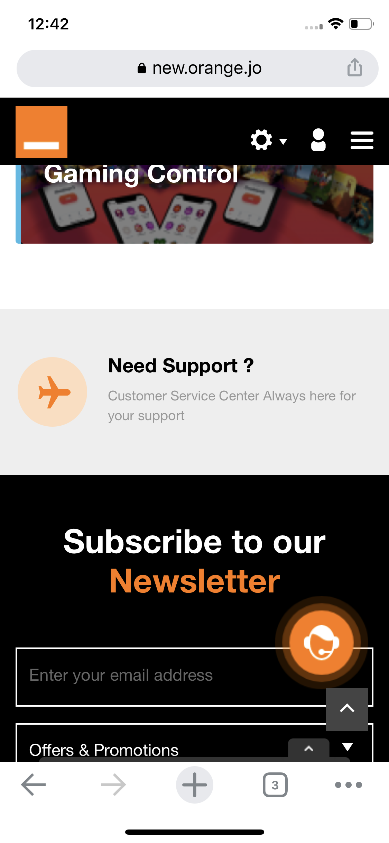

TABLET RESPONSIVE TEST:

* Bread crumbs doesn’t exist.



* Paragraph in the banner isn’t readable.



* There is no arrow at the right of this section and there is too much empty space in here.

